***COLESHILL SOCIAL CLUB***

**RECOMMENDED SERVICES**

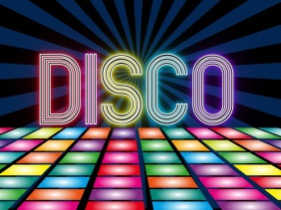

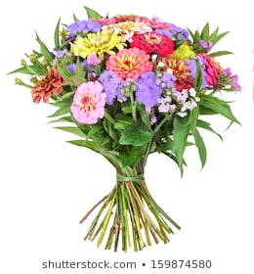

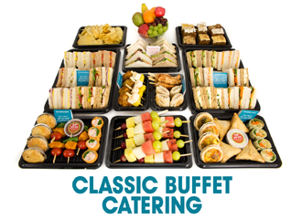



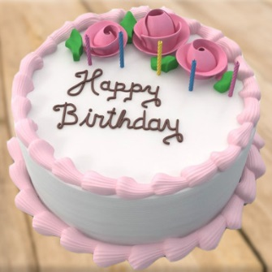

**MUSIC**

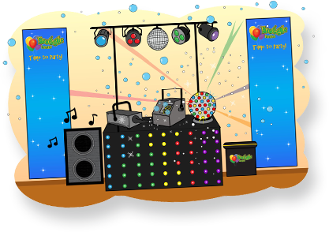

**DCP DISCO**

Blue Icon Telephone Web Telephone Telephon 07830 060664

Image result for images of website logo [www.dcpdisco.co.uk](http://www.dcpdisco.co.uk)

(This can also be booked though the club when booking a function room)

Evening Party Functions - £200.00

Children’s Parties - £80.00 for 2 hours. Prizes, Games & Disco.

Karaoke - £100.00 with Screen, Microphones & Disco.

Race Nights - £100.00. All equipment and hosting.

Christenings, funerals, other events, prices on request.

**ENTERTAINMENT AGENTS**

**J K ENTERTAINMENT**

Jackie O’Shea

Blue Icon Telephone Web Telephone Telephon 0121 313 0504

Blue Icon Telephone Web Telephone Telephon 07977 041628

C:\Users\CassisiD\Desktop\mail-icon-256.png [info@Jkentertainmentagency.co.uk](mailto:info@Jkentertainmentagency.co.uk)

Image result for images of website logo www.@Jkentertainmentagency.co.uk

**DARREN DAY MUSIC LTD**

Blue Icon Telephone Web Telephone Telephon 07853 328638

C:\Users\CassisiD\Desktop\mail-icon-256.png [darindaymusic@gmail.com](mailto:darindaymusic@gmail.com) OR [info@darindaymusic.com](mailto:info@darindaymusic.com)

Image result for images of website logo www.darindaymusic.co.uk

 Information



**Example of a few acts**

**Bee Gees – Stayin Alive**

For over 2 Decades as the world’s premiere tribute to the Bee Gees, Staying Alive continue to bring the house down with their faultless recreation of the distinctive vocals and harmony sounds of the Bee Gees, with timeless classics such as 'How Deep Is Your Love', 'Night Fever', 'Tragedy', 'Massachusetts', 'Gotta Get A Message To You' as well as many other great hits.

**Party Celtica**

Taking the Celtic Experience to the next level, we present "Party Celtica", a new Party band for the new decade! This powerful trio boasts two current members of top party band "Rang-A-Tang", drummer/vocalist Daz Noden, and accordion, acoustic guitar, mandolin, penny whistle, bass and vocal from Richie Parrott, with vocals and keyboards from established solo artist, Marie Kelly. Together they create an exciting live show which features hit songs from all eras of the Irish Celtic Scene, including hits by The Corrs, The Pogues, The Dubliners, Van Morrison and many more**.**

**UB40 – Rats in the kitchen**

Rats in the Kitchen are the world’s Number One UB40 Tribute. Performed by a fully live 8-piece band. They have a massive repertoire of heart pounding, foot stomping reggae hits spanning 25 years! From early hits, such as "King" and "Food For Thought" from the first album, Signing Off, through to songs from the album, Who You Fighting For. With some 80's ska thrown in for good measure and plenty of audience participation.

**Glam45**

They deliver an authentic 70's Glam Rock Experience, with renditions of classic 70's Glam and Glitter tunes, with original 70's Glam Rock outfits and modern reproductions of classic 70's Glam Rock styles. Playing all the greats from the Sweet, Marc Bolan, T-Rex, David Bowie, Mott the Hoople, The Glitter Band, Roxy Music, Suzi Quatro, The Arrows, Abba, Alvin Stardust, Mud, Showaddywaddy.

**Tina Turner – Taste Of Tina**

Niqi will blow you away with her tribute to the Nutbush Queen Tina Turner (you may also have seen her shaking Simon Cowell into a frenzy on the X factor as Bupsi). With such a strong set list that includes 'Let’s Stay Together, Proud Mary, Simply the Best, Steamy Windows, What’s Love got to do with it and many more, the dance floor is guaranteed to be full! So, if you would like your own 'Private dancer' this is the girl to see, boy she can shake that ‘Tail Feather’!

**Swinging Rascals**

The Swinging Rascals are a 21st century Ratpack act, they have been causing musical mayhem, with their tight harmonies and the very best in current and classic swing music. They guarantee a fast-paced foot-tappin’ fun filled evening of quality live music entertainment. The show Includes some of the best Swing tunes from the last 60 years. The Rascals natural friendly banter creates a new style of Rat Pack that just has to been seen. Performing swing favourites like “Mack The Knife”, “That’s Life” and “Come Fly With Me” & many more surprises along the way!

**Motownella’s**

Celebrate NYE in style. The Motownella’s, are an incredibly talented vocal harmony trio, three beautiful ladies with cheeky charm, glitz & glamour, oozing with class. They deliver a fabulous Motown, Pop & Soul night, full of sweet harmonies and captivating choreography, taking you back in time to the era of all things Motown. Make sure you put on your dancing shoes!

**CATERING**

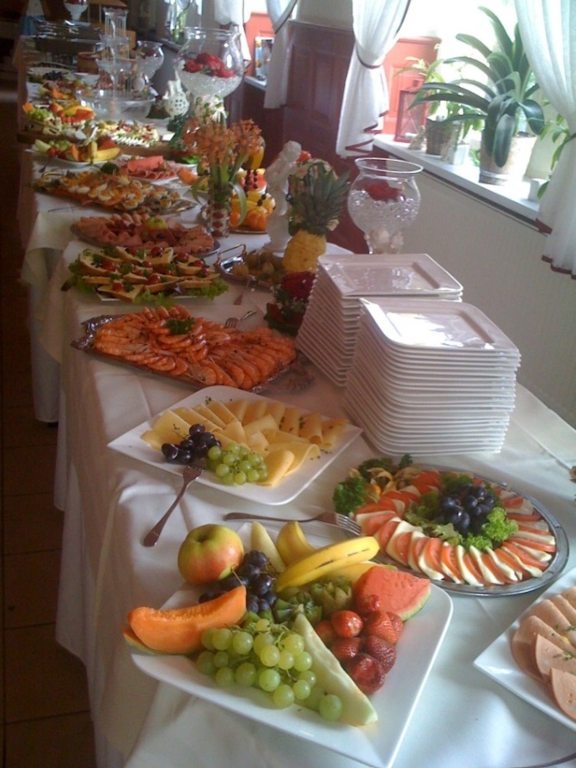

**J&F BUFFETS**

Blue Icon Telephone Web Telephone Telephon 07890 834810

C:\Users\CassisiD\Desktop\mail-icon-256.pngYvettefield@hotmail.co.uk

**UPPER CRUST**

Blue Icon Telephone Web Telephone Telephon 01675 467126

C:\Users\CassisiD\Desktop\mail-icon-256.png [www.Jeanette1967@Hotmail.co.uk](http://www.Jeanette1967@Hotmail.co.uk)

**FLOWERS**

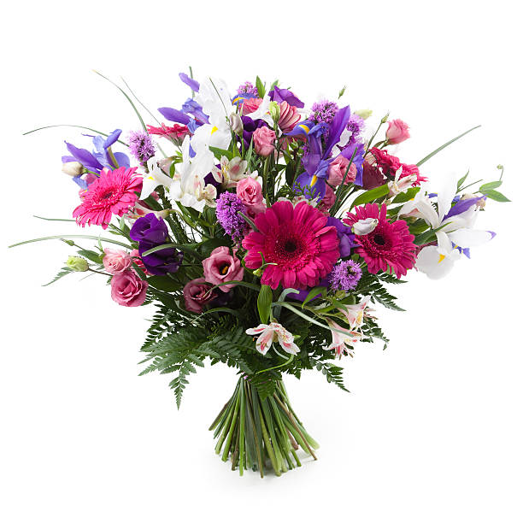

**PENNY JOHNSON FLOWERS**

106 High Street

Coleshill

B46 3BL

Blue Icon Telephone Web Telephone Telephon 07767 376777

C:\Users\CassisiD\Desktop\mail-icon-256.png [www.pennyjohnsonflowers.com](http://www.pennyjohnsonflowers.com)

 Information

**HANDFUL OF FLOWERS**

58 Station Road

Marston Green

B37 7BA

Blue Icon Telephone Web Telephone Telephon 07908 442501

C:\Users\CassisiD\Desktop\mail-icon-256.png [www.handfulofflowersbirmingham.com](http://www.handfulofflowersbirmingham.com)



**PHOTOGRAPHER**

**ELECTRIC BLUE**



**Charlotte Eagles**

[www.blueblueelectricblue@hotmail.co.uk](http://www.blueblueelectricblue@hotmail.co.uk)



**ROOM DECORATION AND BALLOONS**

**MR PINKS PETALS AND PARTIES OF COLESHILL**

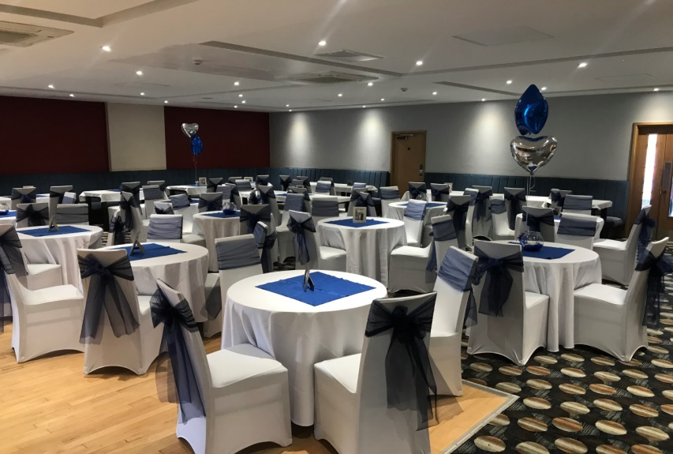

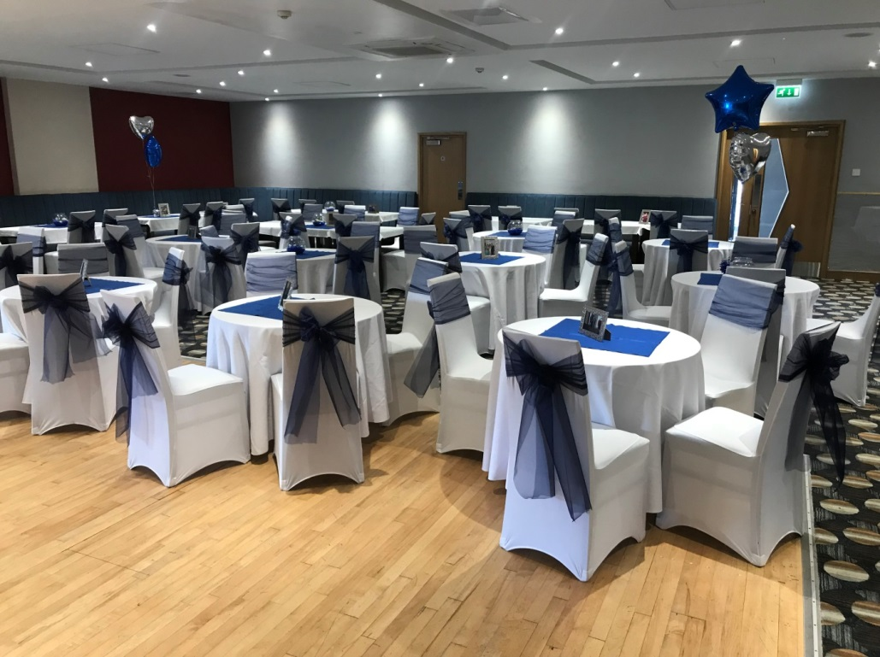

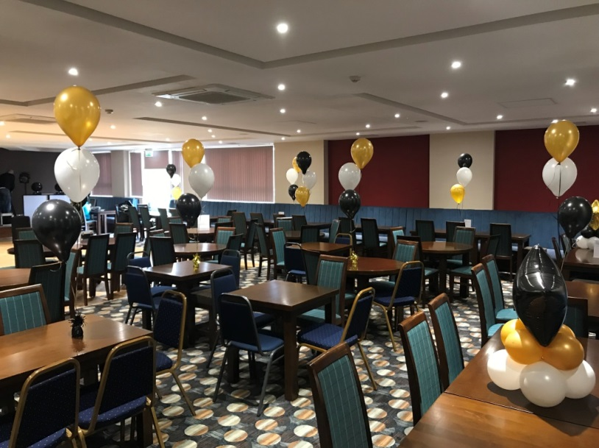 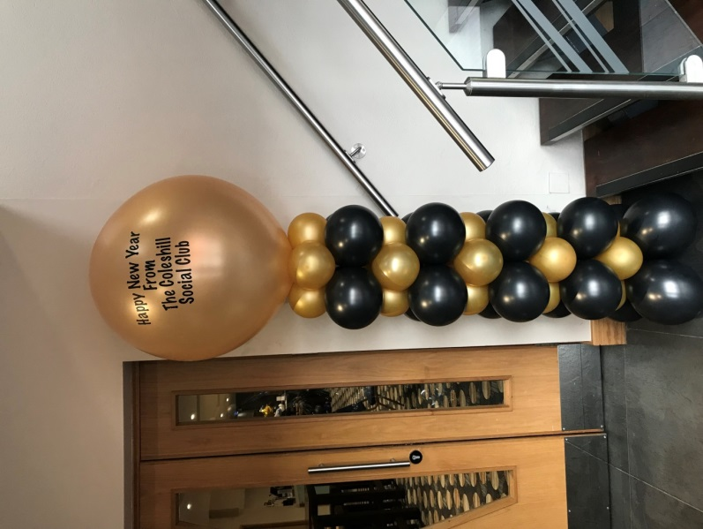

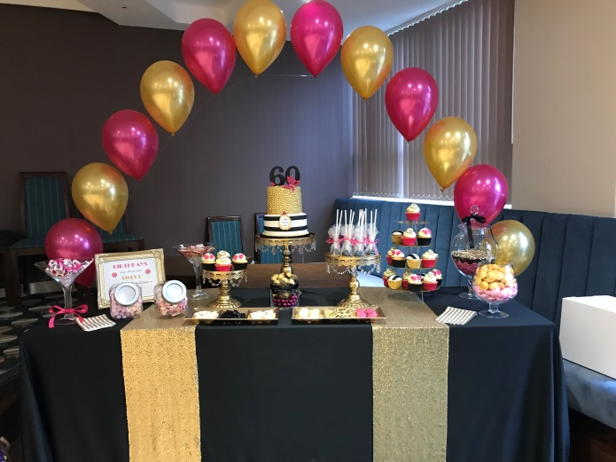

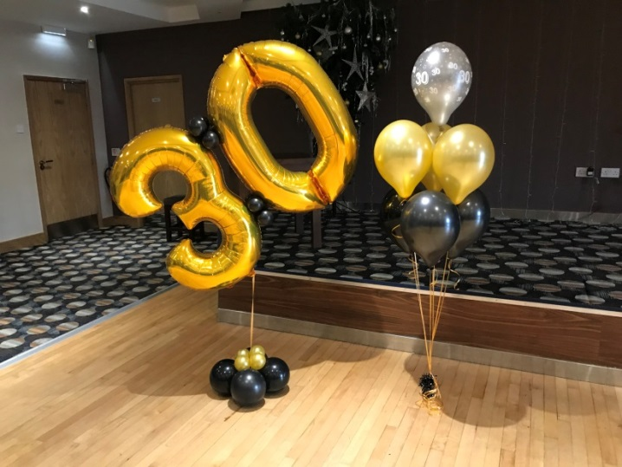

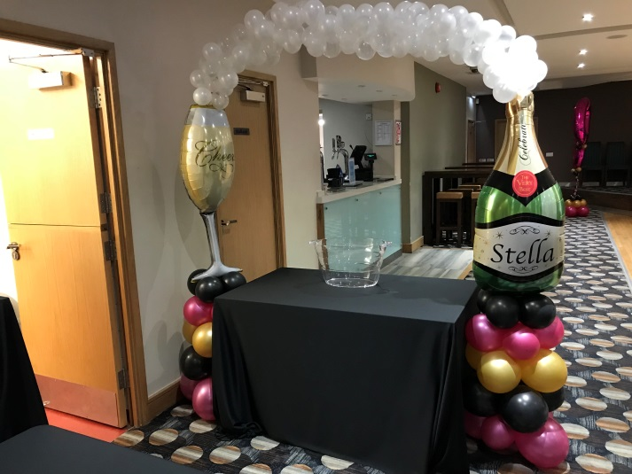

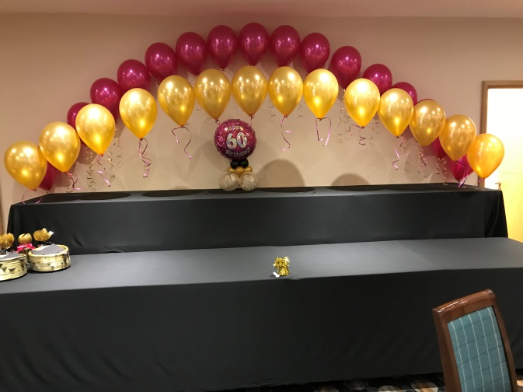

07809693039

[Balloons@mrpinks.pink](mailto:Balloons@mrpinks.pink)